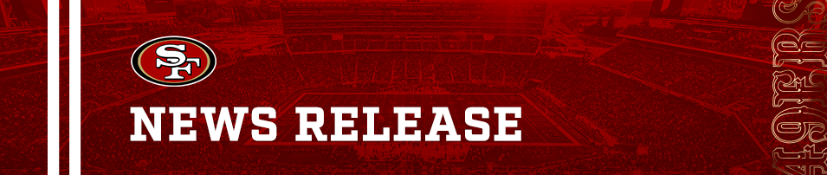

FOR IMMEDIATE RELEASE
October 24, 2023

VENARDI ZURADA NAMED AS OFFICIAL INJURY ATTORNEYS OF THE SAN FRANCISCO 49ERS
SANTA CLARA, Calif. – Today the San Francisco 49ers have announced a new multi-year partnership with Venardi Zurada, a Bay Area-based law firm that specializes in personal injury, and employment law. The deal names Venardi Zurada the “Official Injury Attorneys of the San Francisco 49ers.”
Aligned in their commitment to supporting communities across the Bay Area, Venardi Zurada has become the official presenting partner of the 49ers Foundation 50/50 Raffle, which benefits 10 different community programs and non-profits each season. Fans participate in the raffle by purchasing a ticket for a chance to win half of the total net ticket proceeds - the other half benefits a local charity through the 49ers Foundation. Since 1991, the 49ers Foundation has invested over $60 million back into the community to support youth and provide the tools they need to tackle what is possible. Most recently, the raffle raised a regular season record breaking $196,511 during the 49ers vs. Cowboys game on October 8th.
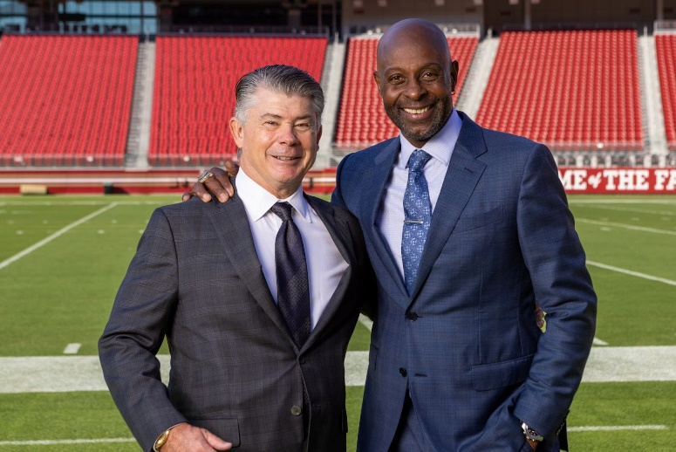
Jerry Rice, the legendary 49ers alumni, and Honorary Chairman of the 49ers Foundation, has joined forces with the firm as their spokesperson. He is featured in promotional materials and commercials that will be broadcast throughout the Bay Area during the 49ers' 2023-2024 season.
Venardi Zurada additionally holds the position of associate partner at 49ers Cal-Hi Sports, the foremost high school sports show in the nation, dedicated to showcasing positive sports moments within Bay Area high schools. As part of this partnership, the firm serves as the presenting partner for the "Hometown Hero" segment, which spotlights Bay Area High School boosters who have made significant contributions to their respective programs through donations and dedicated volunteer work.
“Our loyal supporters are the lifeblood of our franchise, and this partnership underscores our commitment to their well-being.” said Kevin Hilton, VP, Corporate Partnerships. “Just as the 49ers strive for excellence on the field, Venardi Zurada ensures that all who cheer on the red and gold have the support to win their battles in the courtroom.”
With offices in both Oakland and Walnut Creek, Venardi Zurada has a distinguished history of delivering exceptional legal representation, advice, and counsel for several decades, securing over $100 million in victories for their clients.
“We’ve been champions of our clients for years, and it’s fitting that we’re partnering with an organization that has a winning legacy like the 49ers.” said Mark Venardi, Partner.
“Venardi Zurada is looking forward to giving back to our shared Bay Area home with the support of the 49ers Foundation, and together, we’re going to create future winners throughout our partnership.” said Martin Zurada, Partner.
Additional partnership elements include the firm receiving inclusion across Levi’s® Stadium on game days, social media channels, TV, and radio commercials throughout the season.
About The San Francisco 49ers:
The San Francisco 49ers, owned by Denise and John York, currently play in the NFC West division, and have won five Super Bowl trophies including Super Bowl XVI, XIX, XXIII, XXIV and XXIX. The franchise also has seven conference championships and 20 divisional championships and was the first major league professional sports team to be based in San Francisco over 75 years ago. Please visit 49ers.com and follow the 49ers on Facebook and Twitter @49ers.

About Venardi Zurada:
Venardi Zurada has been fighting for the rights of the injured and those mistreated in the workplace. They are a local personal injury and employment firm dedicated to winning hometown battles and achieving big wins for their clients. They offer free consultations and get paid only when they obtain money for their clients. To learn more about Mark Venardi, Martin Zurada, and the rest of the Venardi Zurada legal team please visit https://www.vzlawfirm.com

Media Contact
Rachel Romov, San Francisco 49ers
Rachel.Romov@49ers.com | 415.601.2990
-- 49ers.com --

